START A WORKPLACE CAMPAIGN
United Way of Central Kansas raises funds each year to support 22 non-profits in Barton & Pawnee Counties. We raise and distribute charitable dollars to agencies that offer health and human services to improve the lives of everyone in our community. The majority of those funds are raised through workplace campaigns.
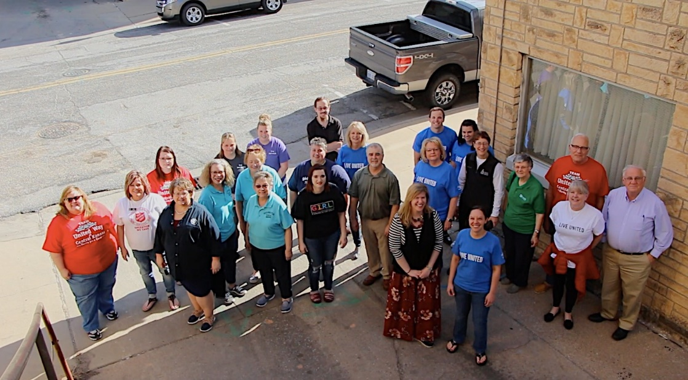

BENEFITS OF A UNITED WAY WORKPLACE CAMPAIGN
Improve employee attraction, engagement, and retention.
Many employees are looking to work for businesses who share their values. By offering employees an easy way to donate and volunteer their time, your company can convey that the company is concerned with making positive change in our community, which can help you attract and retain employees. Given the value that many job candidates place on working for companies with extensive giving programs that enable them to contribute to charitable causes, corporate philanthropy has emerged as a key differentiator among employers. This is highlighted by a statistic from Rosemary Haefner, CareerBuilder’s global vice president of Human Resources, suggesting that nearly three in four candidates would accept less than their lowest target salary to work for a company with a favorable brand.
Increased employee morale.
Companies that run annual employee campaigns document higher morale and teamwork. Employees learn about services provided by United Way and work together to plan and engage in fun activities to raise money as a company: barbecues, raffles, games, and special incentives for givers, like jeans day, bonus day off, or a prime parking spot.
Increased employee community knowledge and involvement.
United Way of Central Kansas funds 22 local non-profits and regularly collaborates with many more. These partnerships, and your business’ support of UWCK, means that your employees will know more about the services available in the community and the programs and events that all these non-profits provide for the community.
Tax benefits.
All donations to United Way are tax deductible.
Community recognition.
When you run a United Way campaign you join a ranks of hundreds of individuals and dozens of other companies who have come together to support our community.

COMMUNITY BENEFITS FROM YOUR CAMPAIGN:
Local focus.
Your United Way gift stays here to help our local community. 98% of funds raised by UWCK stay here. Suporting some of the best local health and human service programs in our area. Your gift provides child care, youth programs, elder services and support, funding for victims of domestic violence and child abuse, housing assistance, and other social service programs.
Quality agencies.
Our United Way ensures that your money funds quality agencies to address the most important community needs. Our volunteer Board of Directors from across the area review agency budgets, programs and outcomes to ensure that our dollars have the most impact.
Additional resources.
United Way Community Partners
Barton County Young Men’s Org Barton County Youth Care Caring Hands Daycare Catholic Charities of SW KS
Central Kansas CASA Cerebral Palsy Research Foundation Commission on Aging ElderCare, Inc Ellinwood Heritage Senior Center Family Crisis Center Girl Scouts of KS Heartland Habitat for Humanity
Great Bend Children’s Learning Ctr Hoisington Food Bank Hoisington Historical Society Meals on Wheels
Immediate Intervention Programs Orphan Grain Train Toys for Tots VMB Development
Volunteers in Action/AmeriCorps Seniors Salvation Army-Barton & Pawnee
Community Impact Programs
Born Learning Trails Crunch Out Obesity Dolly Parton’s Imagination Library Literacy Kits
Reality U #RealWorld Box of Love Stuff the Bus Hands Only CPR
United Way connects people to services and assistance across the region through our information and referral line. This information is free and available to everyone. Call 2-1-1, it’s free and confidential. You can also search our on-line community services directory at https://211kansas.myresourcedirectory.com.
Safety net.
You never know when you, a family member or a coworker will need help from a health or human service agency. That’s why we cast a wide net of programs to help. You can find a full list of programs we fund via our Community Partners. https://www.uwck.org/community-partners.

HOW CAN I HELP?
Run an employee campaign.
We have a strong community thanks to the dozens of local companies that offer their employees the opportunity to give back through a workplace campaign. Please give your employees the chance to join in this community-wide effort.
Give a corporate gift.
Our community has a high level of United Way corporate giving. A Corporate gift illustrates your organization’s commitment to the community through the United Way. This can be through matching employee workplace donations or sponsorship of a United Way event.

Hold a special event or encourage giving.
Many local companies hold special event fundraisers to for the United Way. Some ideas include bake sales, candy sales, cook-outs, change wars, garage sales and golf tournaments.
Encourage your employees to give by offering incentives for participation. A local business, First Kansas Bank, increased giving from 36% participation to 100% by offering a bonus vacation day to any employee who donated their “Fair Share”. The fair share calculation is 25% of one hour of pay, per pay period. For example, they make $15/hr, their contribution per two week pay period is $3.75. The power of the incentive is that it gets everyone contributing and doing so with a happy heart! If payroll period is monthly, you would adjust that to a higher percentage. As a further incentive, the location/department with the highest percentage of participation was given another vacation day on top of that. Their giving increased by 200%!! Their business is now a Pacesetter Top 10 Company for UWCK.

READY TO TRY A CAMPAIGN?
If you’d like to introduce a workplace campaign to your company, contact Charell Owings at 620-792-2403 or by email at unitedwaycentralks@hotmail.com.

