2024

**Charell Owings**

**United Way of Central Kansas**

**620-792-2403**

[**unitedwaycentralks@hotmail.com**](mailto:unitedwaycentralks@hotmail.com)

[**www.uwck.org**](http://www.uwck.org)

**1125 Williams, Great Bend, KS 67530**

Campaign Coordinator Guide

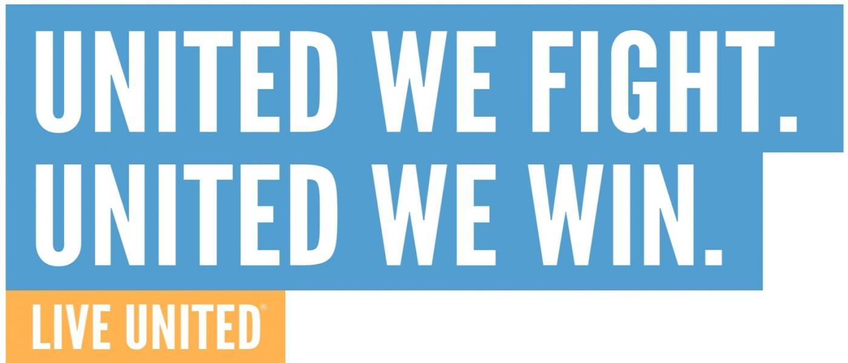

Workplace Campaign Options

* In-person presentation(s) with paper or mobile (or both) pledge forms that are distributed during presentation.
* Additional campaign promotion by Workplace Campaign Coordinator (emails, workplace special events, fundraisers, etc.)
* Complete Tentative Commitment and send to UWCK via email or fax.
* Company-branded online website pledge form on United Way’s website.
* Campaign communications shared electronically by CEO or Workplace Campaign Coordinator. United Way will provide:
  + Prewritten email template for use.
  + Link to short overview video
  + Link to online pledge form.
* Additional campaign promotion by Workplace Campaign Coordinator (emails, workplace special events, fundraisers, etc.)
* HR will be supplied a spreadsheet of donations for payroll deduct at close of campaign.
* Complete Tentative Commitment and send to UWCK via email or fax.

OnlineMPAIGN GAME PLAN

Rollover

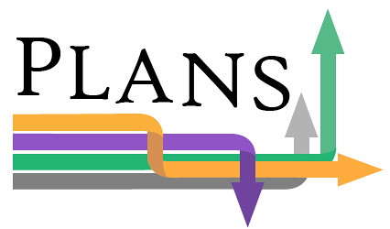PAIGN GAME PLAN

Traditional

MPAIGN GAME PLAN

* Workplace can choose to rollover pledges from last year’s campaign and forgo presentation option for 2023.
* Permission email/text should be sent to current employee donors from company as notification of rollover with option for employee to opt out.
* Cash and bill-me options will be billed for their 2023 donation.
* Additional campaign promotion by Workplace Campaign Coordinator (emails, workplace special events, fundraisers, etc.)
* Complete Tentative Commitment and send to UWCK via email or fax.

Find Success in your Workplace

**To discuss your workplace campaign, contact Charell Owings at 620-792-2403 or** [**unitedwaycentralks@hotmail.com**](mailto:unitedwaycentralks@hotmail.com)**.**

**Need ideas to encourage workplace giving? Let us know!**

* Promote your campaign! Ask your CEO to send an email of support to all staff detailing how your business supports UWCK in addition to the Workplace Campaign. Check out our email template but make sure to personalize it for your business.
* Encourage giving! The number one reason people say they don’t give is because they weren’t asked. Just remember that contributing is a personal matter and should be kept confidential. Pressure to give is unacceptable.
* Follow-Up! Make sure you reach all employees and ask that everyone return their pledge card, even if they don’t intend to give. If you meet with the employee one-on-one, make sure to share why you give and how UWCK meets local needs. If you have questions that you can’t answer, contact UWCK for help.
* Celebrate your success! Hold a celebration event (ice cream social, pizza party, etc.) to announce your results and thank your donors. Every campaign is worth celebrating.
* Say Thanks! Thank your CEO and management for their support of the campaign and recognize and thank each donor. And don’t forget your committee members! A note or a small treat left on their desk a great way to let them know their support is appreciated.
* Increase participation by establishing a company-wide incentive for meeting your goal, offering individual incentives, such as special prize drawings or jeans day, emphasize corporate match or donation, and highlight the ease of payroll deduction.